Data science
Data Science is an interdisciplinary field that uses statistics, mathematics, programming, machine learning, and data analysis techniques to collect, process, analyze, and interpret structured and unstructured data to extract meaningful insights, identify patterns, make predictions, and support data-driven decision-making.
It is an interdisciplinary field focused on extracting knowledge and insights from data.
It involves data collection ,cleaning ,analysis ,visualisation.
Data Analytics: Domains and Use Cases
Domain | Use Cases
Healthcare | Patient analysis, disease prediction, hospital resource planning, medical research
Finance & Banking | Fraud detection, credit scoring, risk analysis, investment analysis
Retail & E-commerce | Customer behavior analysis, sales forecasting, product recommendations, inventory management
Education | Student performance analysis, dropout prediction, personalized learning
Manufacturing | Predictive maintenance, quality control, production optimization
Marketing | Customer segmentation, campaign analysis, sentiment analysis, advertising optimization
Transportation & Logistics | Route optimization, traffic prediction, delivery tracking, demand forecasting
Agriculture | Crop prediction, soil analysis, yield forecasting, smart irrigation
Sports | Player performance analysis, match prediction, injury prevention, team strategy
Government & Public Services | Population analysis, public resource planning, crime analysis, smart-city management
Telecommunications | Customer churn prediction, network optimization, usage analysis
Energy & Utilities | Energy consumption forecasting, demand management, equipment monitoring
Cybersecurity | Threat detection, anomaly detection, security monitoring
Environmental Management | Pollution monitoring, climate analysis, waste management, disaster prediction

Machine Learning
It is a field of study That enables systems to learn from data and improve over time without being explicitly programmed.
Principles
Algorithms identify patterns within data

Character A is a byte
M B<GB <TB <PB <EB

Machine Learning
-Supervised
Classification
Regression
-Unsupervised
Clustering
Association
-Reinforced
AI Intelligence
The simulation of human intelligence processes by machines,particularly computer systems.
Principles
Encompasses a broad range of capabilities ,including reasoning

WHY ML IS THE FUTURE?
Transformative Technology : ML is reshaping industries and everyday life
Rapid Growth: The field is evolving quickly with increasing investments
Widespread Adoption: Businesses and Industries are integrating ML into their Work.

Advantages

Automation
Predictive Analysis
Personalization

FATHER OF AI
John MaCarthy

1961 – Ist ChatBot Eliza
2011- Watson, IBM
Daily Use Of AI
Navigation

AI TOOLS
Teachable Machines
TensorFlow.js
Adobe FireFly
GFPGAN
Data Science Life Cycle
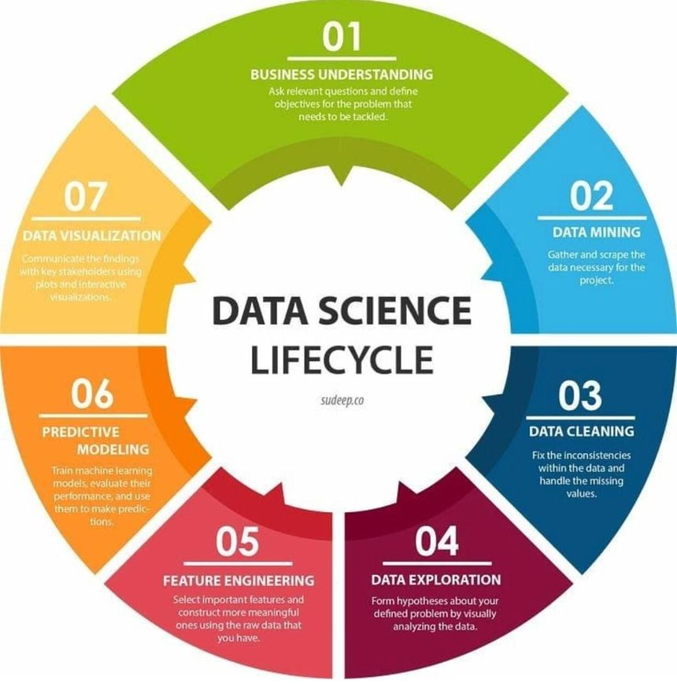

Data visualization is communicate the findings with key stakeholders using plots and interactive visualization.
Data exploration form hypothesis about your defined problems by visually analyzing the data.

